The Art of Composing Pictures: 7 Rules of Composition

SIMPLICITY
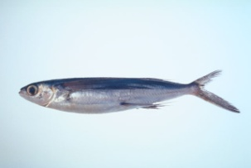
- Choose simple, uncomplicated backgrounds.
- Avoid competing with unrelated subjects in your composition.
- Move in close.
- Place subject slightly off center.

LINES
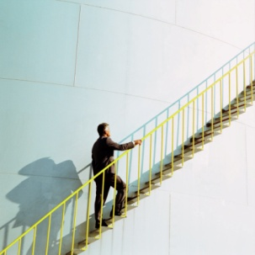
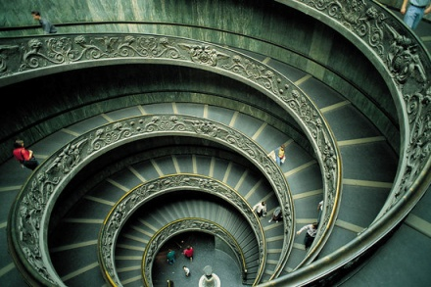

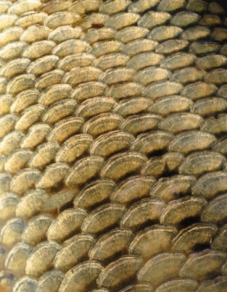
- Keep your photograph simple.
- Use lines to lead viewer into picture’s center of interest.
- Use “S” curve to add interest.
- Use Geometric shapes to add interest.

BALANCE
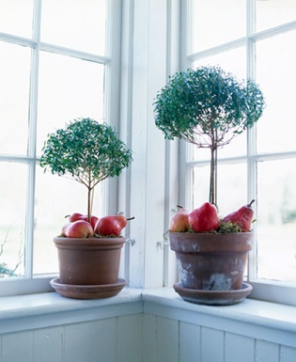

- Balance composition symmetrically or asymmetrically
- Use balance that unifies, not divides.
- Use arrangement of shapes, color, areas of light and dark in a complementary way.

AVOID MERGERS
- Remember to look at your background.
- Choose simple backgrounds.
- Change point of view by moving left or right, up or down.
- Don’t cut off people’s heads or feet.

CROPPING

- Use cropping to correct or improve your photograph.
- Include portions of photograph that are most important.
- Crop horizontally or vertically.

FRAMING
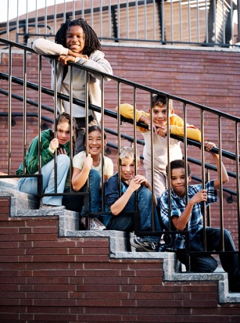
- Use foreground (i.e. trees or foliage) to frame subject.

RULE OF THIRDS
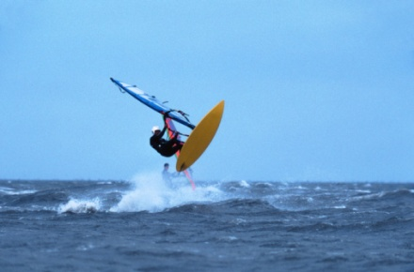

- Avoid placing subject in the middle of the photograph.
- Place horizon line at top or lower third of photograph.
- Leave space in front of moving subjects.
- Place subject on one of the four key positions.

Assignment: The student will view the video, “The Art of Composing Pictures”. The student will find 5 examples for each of the 7 Rules of Composition on the internet. The student will then shoot digital pictures with the intent of capturing the 7 Rules of Composition. The student will turn in 35 [5 for each of the 7 Rules] internet pictures as a PhotoShop Contact Sheet and 14 - 4” x 6” jpg files, 300 resolution, original digital prints, 2 for each of the 7 Rules of Composition. The student’s work will be turned in via the teacher’s folder on the S:\ Drive in the following manner: S:\Communications\Photography\4000 - Photo I\ Student Drop\Teacher\Assignment folder. The student’s file will be labeled the following way: last name_first name_assignment name_final and be a jpeg file.

Purpose: The students will learn the Seven Rules of Composition: Lines, Framing, Rule of Thirds, Simplicity, Cropping, Mergers, and Balance. Through the creation of a portfolio of images collected from the internet, the student will demonstrate their elementary understanding of these Seven Rules of Composition. The students will further show their mastery of the Seven Rules of Composition by shooting digital pictures the intent of capturing each of the seven rules in an original piece of work (picture). The students will show mastery by turning in one photo for each of the Seven Rules of Composition.
VAPA Content Standards Met:
1.1 Identify and use the principles of design to discuss, analyze, and write about visual aspects in the environment and in works of art, including their own.
1.2 Describe the principles of design as used in works of art, focusing on dominance and subordination.
1.4 Analyze and describe how the composition of a work of art is affected by the use of a particular principle of design.
2.1 Solve a visual arts problem that involves the effective use of the elements of art and the principles of design.
2.2 Prepare a portfolio of original two-and three-dimensional works of art that reflects refined craftsmanship and technical skills.
3.2 Identify and describe the role and influence of new technologies on contemporary works of art.
4.3 Formulate and support a position regarding the aesthetic value of a specific work of art and change or defend that position after considering the views of others.
4.5 Employ the conventions of art criticism in writing and speaking about works of art.

Grading Rubric: Rate your pictures from 1 to 6 in each of the following categories.
ALL items marked with ► must be graded 3 or higher to pass the assignment. Any ► item marked 0, 1, or 2 must be fixed to a 3 to pass assignment.
► = ES&C | Lowest -------- Highest |  |  |  |  | EC
► Internet pictures | 1 | 2 | 3 | 4 | 5 | 6 | 35 pictures [5 of each rule] from the Internet printed using PhotoShop’s Contact Sheet function.
► Presentation of 7 Rules by Pictures | 1 | 2 | 3 | 4 | 5 | 6 | Presentation enhances work. Each picture labeled appropriately. Name & Period on Contact Sheet.
► File Name | 1 | 2 | 3 | 4 | 5 | 6 | All files renamed properly.
► File Type | 1 | 2 | 3 | 4 | 5 | 6 | All files converted to JPEG format.
► Size | 1 | 2 | 3 | 4 | 5 | 6 | All pictures proper size.[ 4”W x 6”H or 6”W x 4”H ]
► Resolution | 1 | 2 | 3 | 4 | 5 | 6 | Resolution is 300 dpi for all
► Uploaded | 1 | 2 | 3 | 4 | 5 | 6 | Files uploaded correctly to S:\ drive.
► Simplicity [2] | 1 | 2 | 3 | 4 | 5 | 6 | Shows Simplicity. | All pictures taken by the student who is turning in this grading sheet. This student CANNOT be in any of the pictures.
► Lines [2] | 1 | 2 | 3 | 4 | 5 | 6 | Shows Lines.
► Balance [2] | 1 | 2 | 3 | 4 | 5 | 6 | Shows Balance
► Mergers [2] | 1 | 2 | 3 | 4 | 5 | 6 | Shows Merging
► Cropping [2] | 1 | 2 | 3 | 4 | 5 | 6 | Shows Cropping
► Rule of Thirds [2] | 1 | 2 | 3 | 4 | 5 | 6 | Shows Rule of Thirds
► Framing [2] | 1 | 2 | 3 | 4 | 5 | 6 | Shows Framing.
Creative | 1 | 2 | 3 | 4 | 5 | 6 | Photos are interesting and Creative.
Questions | 1 | 2 | 3 | 4 | 5 | 6 | Questions on back answered.
Rubric | 1 | 2 | 3 | 4 | 5 | 6 | Self scored.
Meets Deadline | 1 | 2 | 3 | 4 | 5 | 6 | Meets deadline.
Assignment | 1 | 2 | 3 | 4 | 5 | 6 | Meets assignment criteria
 |  |  |  |  |  |  | /95 Total Points

Answer the following questions. You do not need to use complete sentences, but your responses must be understandable and legible.
- Describe how filters are used when printing pictures in Traditional Photography.
  - Where is a filter placed?

  - How do you know which filter # to use?

  - What does a filter do? Why would you use a filter? [Answer only one question.]

- How do the 7 Rules of Composition help you take better pictures?

- Define these terms:
  - Asymmetry

  - Balance

  - Composition

  - Curvature

  - Line

  - Movement

  - Negative

  - Positive

